**MODULE 2: HOMEWORK ASSIGNMENT**

**Name:** Pravallika Devi Vallabhaneni

**Student ID:** 11662020

**PART 1:**

* Initially install Tableau and Tableau Prep as per the professor’s instructions in Module2- Content.
* Then, I downloaded the “**Quarterly Spending**” dataset which is required for this homework assignment from the Canvas Module.
* A screenshot of a computer

  Description automatically generatedDouble click on the Data set to open in Excel sheet, as shown below.
* 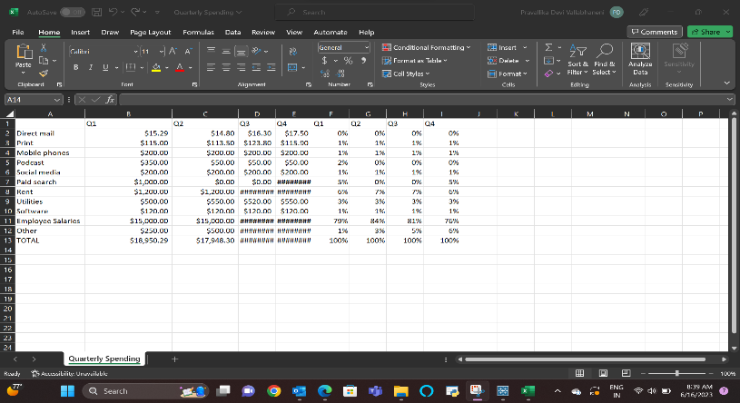Analyze the data in the given data set and clean the data set by deleting the null rows as shown below.
* A screenshot of a computer

  Description automatically generatedOpen Tableau and open the cleaned Quarterly Spending dataset in **DATASOURCE** as per the below image.
* Open new workbook sheet for the data visualizations.
* Here, I’m using **Bar chart, line chart** and the **Heat map** to visualize the cleaned data along with the grand totals.
* For all the worksheets, I had included the Sheet title in the format as **My Last Name: Chart Title**
* **Chart Screenshots:**

1. **A screenshot of a computer

   Description automatically generated with medium confidenceBar Chart**
2. **Line Chart**A screenshot of a computer

   Description automatically generated with medium confidence
3. **A screenshot of a computer

   Description automatically generatedHeat Map**
4. **Expenses Tracker – Bar chart**

* After visualizing the given data set, I will prefer Bar chart and Line charts. From Bar chart we can simply visualize, represent, and understand the given data set. And, from the Line chart we can observe rise and fall of a particular quantity in particular aspects.
* **3 Business Insights:**
* As per the Grand Total from the fig1 **Bar chart**, the company is spending more expenses in **Employee Salaries** and then on the **Rent** when compared with others.
* As per the **Line chart**, we can observe that there is an increase in other expenses quarterly.
* Also, Paid search expenses was decreased and from 3rd quarter it was gradually increases which leads to increasing in 4th quarter expenses. So, if we can decrease the expenses spent on paid search there will be decrease in expenses in 4th quarter.
* From the fig 3 **Heat Map**, we can say that there are few expenses like Rent, Mobile phones, social media, and software maintaining constant prices quarterly.
* From the **Expenses tracker**, if we observe the Grand total column, we can say that the company is spending expenses more in 4th quarter and then in 1st quarter when compared with other quarters.

**PART 2:**

1. **Why Data Visualization is important?**

Data Visualization is so crucial and utilized in all sectors ranging from small to large scale industries.

Now a days, data is everywhere and for every second some trillions of data is getting generated. Evaluating such huge data is a tedious task. In such cases Data visualization is handy where

1. It helps in visualizing the data in the form of suitable charts.
2. Establish the relationship between the attributes.
3. Understands customers behaviors by identifying the patterns.
4. Easy to communicate, understand, interpret, and focuses on major goals.
5. Identified the trends and produce statistics and predicts the future outcomes and estimations.

**Reference:** Boyce, L. (2023). Value of Data Visualization [Video: Value of Data Visualization]. UNT Summer Module#2 Content.

**AREA OF INTEREST:**

I focused on how data visualization is helpful in increasing the revenue of the food industry and understanding the customer behavior pattern in online shopping. I am interested in the areas of **Food industry and online shopping.**

**Screenshot of Data visualization charts in my area of interest.**

1. **FOOD INDUSTRY:**

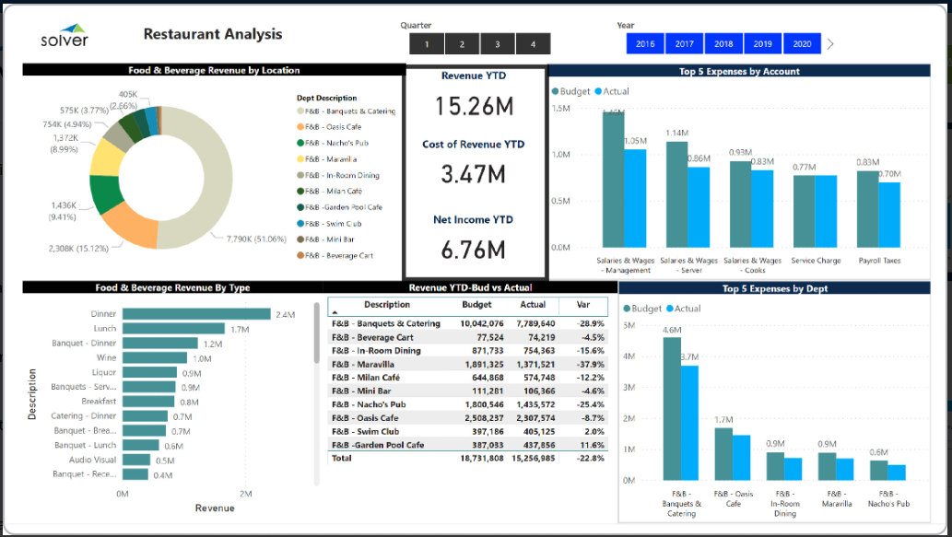

**Discussion for the above data visualization:**

Every organization tends to have a growth towards profit. The above Restaurant analysis helps in identifying customer’s food habits and revenue incurred through it. Analyzing the revenue with the investment. The following insights that I can grabbed from

1. Horizontal bar chart describes which type of menu customers are preferring and revenue generated through it.
2. Vertical chart helps in identifying the budget allocation and actual spending and manages based on customer preference and for future developments.
3. Donut charts help in identifying the location preference of the customers and contribution of each location in revenue.

Additionally, as the professor noted in the presentation, these bar graphs are simple to display and simple for the audience to understand.

**Reference:**

1. <https://www.solverglobal.com/report-budget-forecast-and-dashboard-template-glossary/restaurant-dashboard-for-hospitality-companies/>
2. Boyce, L. (2023). Value of Data Visualization [Video: Exploratory data analysis]. UNT Summer Module#2 Content.
3. **ONLINE STORES:**

**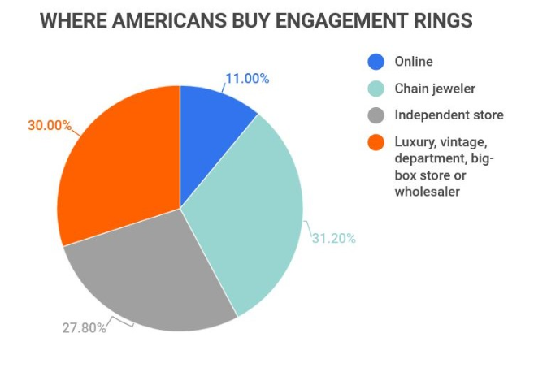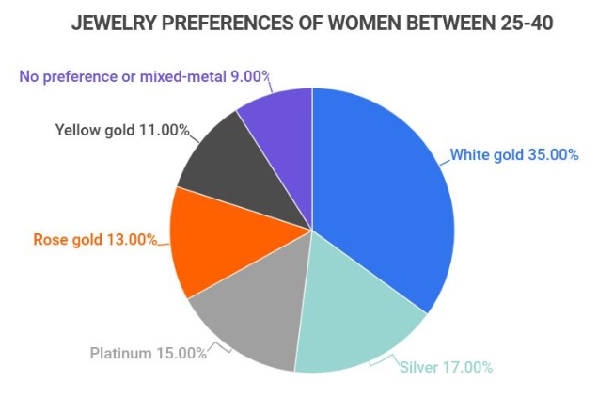  
Discussion for the above data visualization:**

**Pie chart** shows the interest of women’s over different kinds of jewelry and their shopping preference in buying engagement rings.

1. Represents the contribution of sales over different stores in percentages and indicates the improvements and customer behavior.
2. Contribution of jewelry in market in percentages and indicates the interest of women in white gold so different designs can help in more sales.

**Reference:**

<https://www.zippia.com/advice/jewelry-industry-statistics/>